**Subject: PRF192- PFC**

**Workshop 04**

**Objectives:**

1. Managing data using pointers
2. Developing programs using simple menus

**Part 1: Use notebook**

**Exercise 1** (1 mark) : Explain outputs:

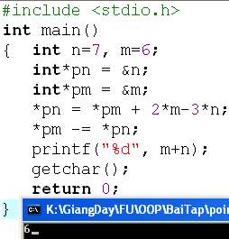

N=7,M=6

*pn=address n

*pm=address m

Pn=6+2*6-3*7=-3=>n=-3

Pm=pm-pn=6-(-3)=9=>m=9

M+n=6

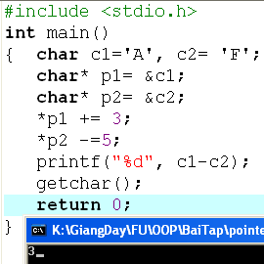

*p1 +=3 => c1= *p1= *p1 +3= c1+3= A + 3= D

* p2  -=5 => c2 = *p2 = *p2 -5= F – 5= A

C1-c2=*p1-+p2=D-A=3

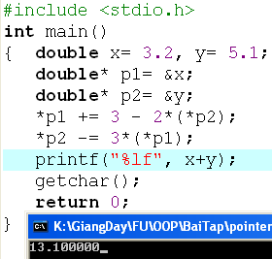

P1=p1+3-2*(p2)=3.2+3-2*5,1=-4=x

P2=p2-3*(p1)=5,1-3*(-4)=17,1=y

X+y=13,1

**Exercise 2: (1 marks) What are outputs**

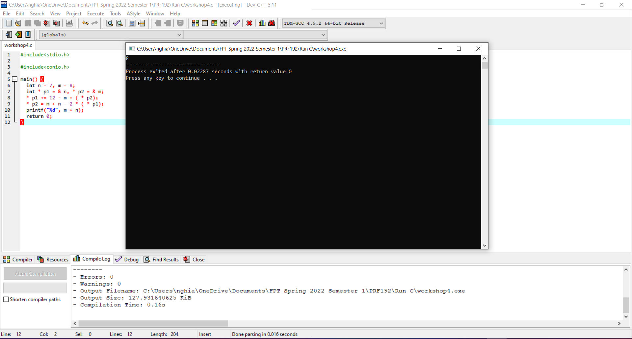

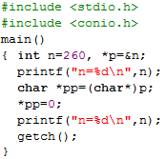

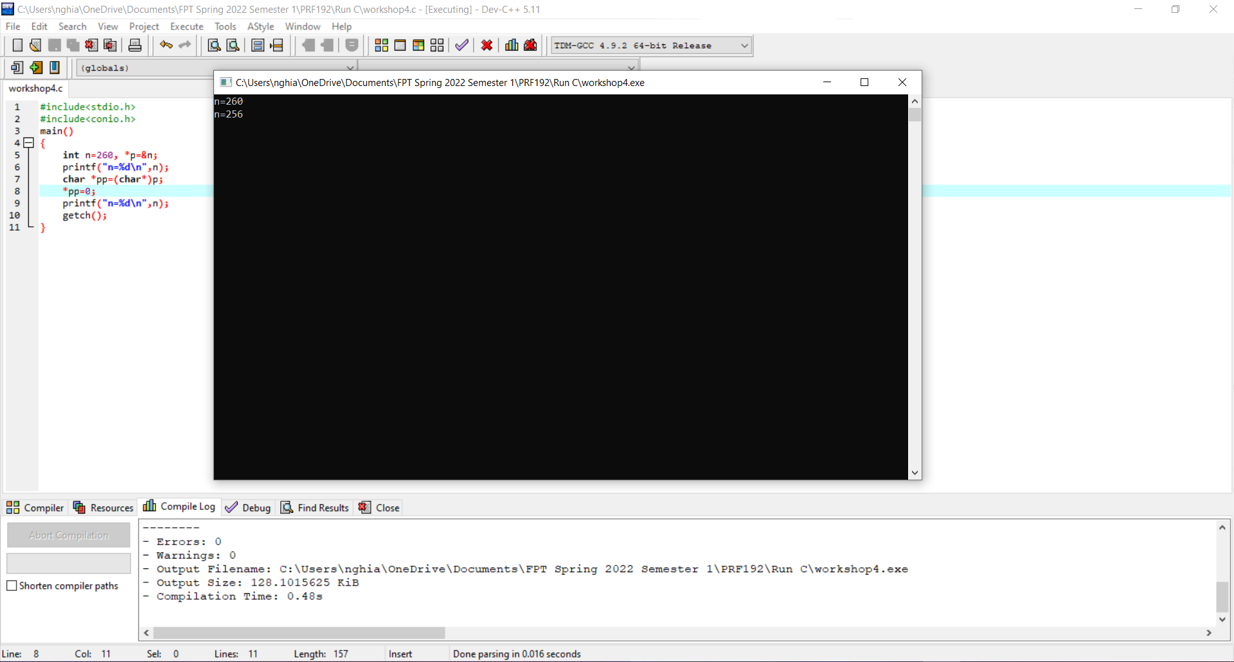

**Exercise 3: (2 marks) Walkthroughs**

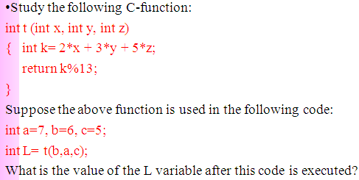

L=2*6+3*7+5*5=88

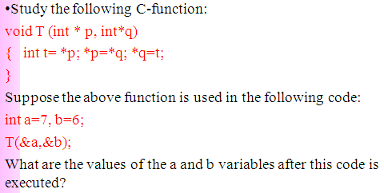

T=7=*p=*q=t=>b=7=>a=6

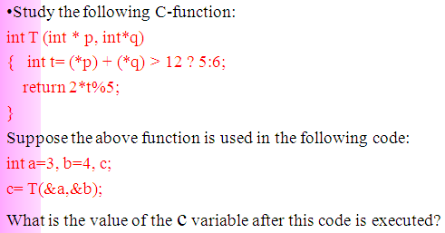

A=*p=3

B=*q=4

(*p)+(*p)=3+4=7<712=>return=(2*6)%5=2

**Part 2: Develop a program using simple menu**

**Program 1(3 marks):**

|  |  |
| --- | --- |
| **Objectives** | Practice implementing a program with simple menu. |
| **Related knowledge** | None |
| **Problem** | Write a C program that will execute repetitively using a simple menu as following:   1. **Process primes** 2. **Print min, max digit in an integer;** 3. **Quit**   **Select an operation:**   1. When user selects the option 1, the program will accept a positive integral number and print out a message about whether the input number is a prime or not. 2. When user selects the option 2, the program will accept a positive integral number and print out the minimum and maximum digit in this number. 3. The program will terminate when user selects the option 3. |
| **Analysis** | **Nouns:**  - positive integral number 🡪 **int n**  - A number represents a choice of user 🡪 **int choice;**  **Functions**:  **int prime( int n) 🡪 see above**  **void printMinMaxDigits( int n) 🡪 see above** |
| **Suggested algorithm (logical order of verbs)** | Begin  Do /* Print out the menu and get user choice*/  { Print out “1- Process primes\n”;  Print out “2- Print min, max digit in an integer \n”;  Print out “3- Quit\n”;  Print out “Select an operation:”;  switch(choice)  { case 1: do  { Input n;  }  while(n<0);  If ( prime(n)==1) Print “ It is a prime\n”;  Else Print “ It is not a prime\n”;  break;  case 2: do  { Input n;  }  while(n<0);  printMinMaxDigits( int n) ;  break;  }  }  while ( choice >0 & choice<3);  End |

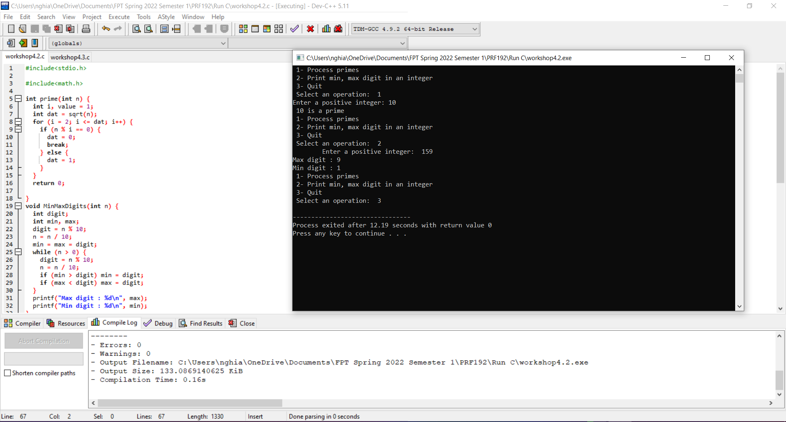

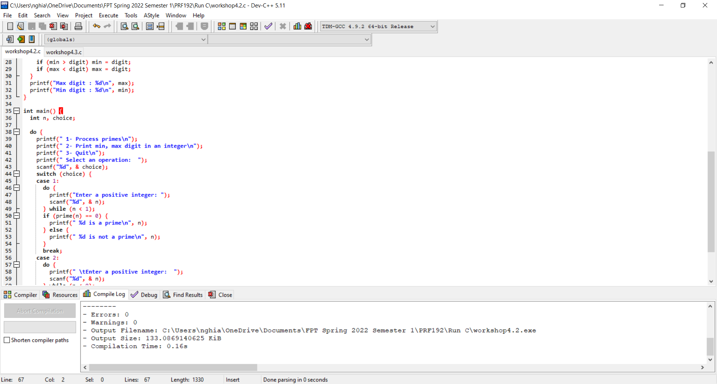

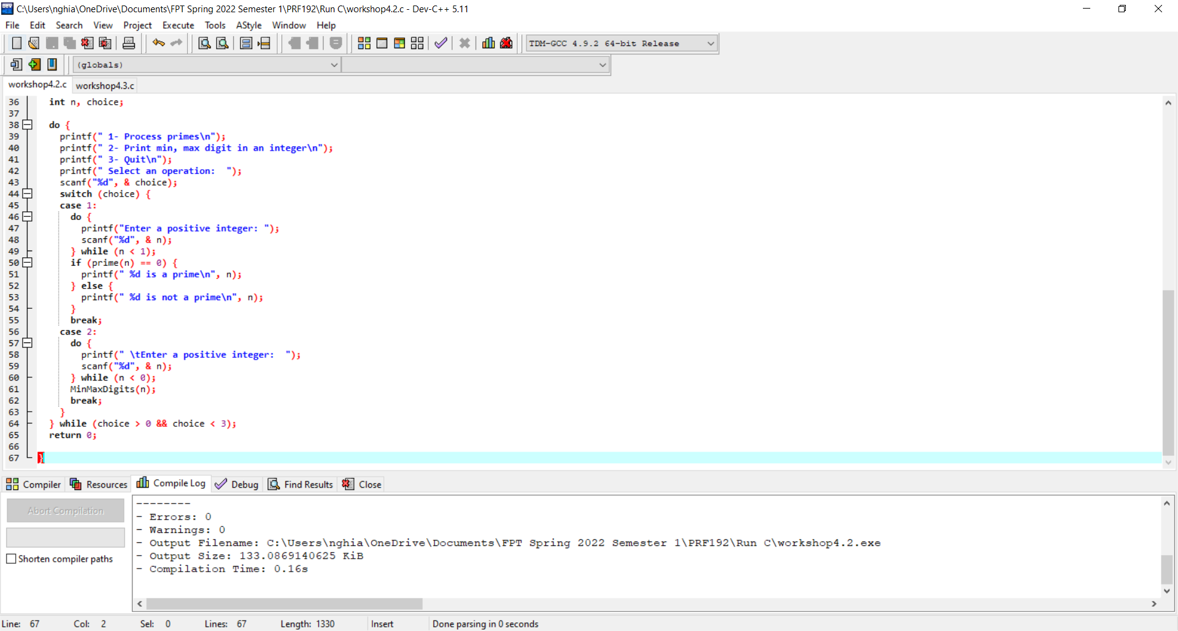

**Program 2(3 marks): ( refer to the workshop 2 for algorithms)**

Write a C program that will execute repetitively using a simple menu as following:

**1-Fibonacci sequence**

**2-Check a date**

**3-Quit**

**Choose an operation:**

1- When the option 1 is selected, the program will accept a positive integral number, called as n, then the first n Fibonacci numbers will be printed out

2- When the option 2 is selected, the program will accept a date then the program will tell that whether this data is valid or not.

3- If the option 3 is selected, the program quits

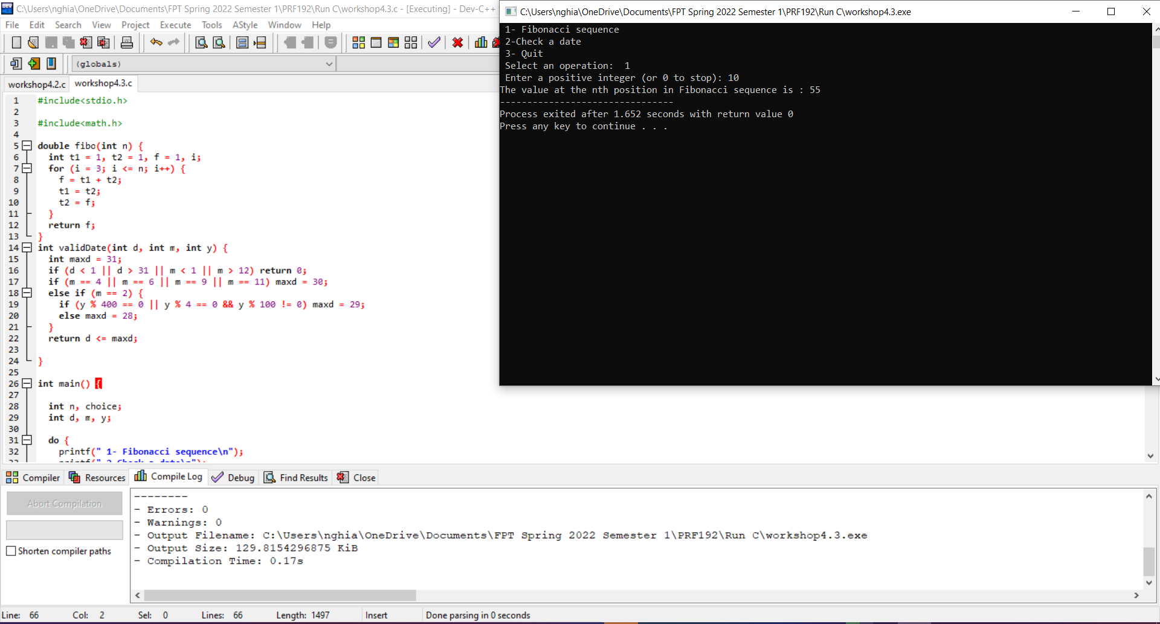

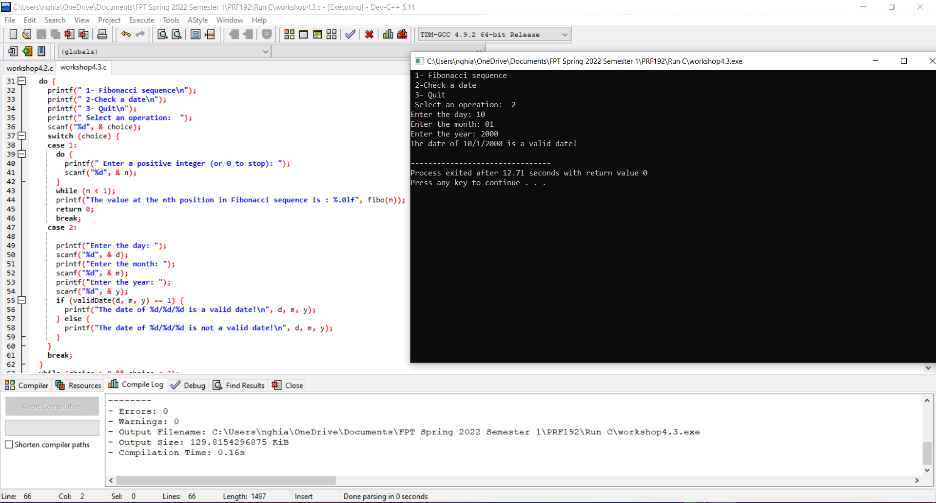

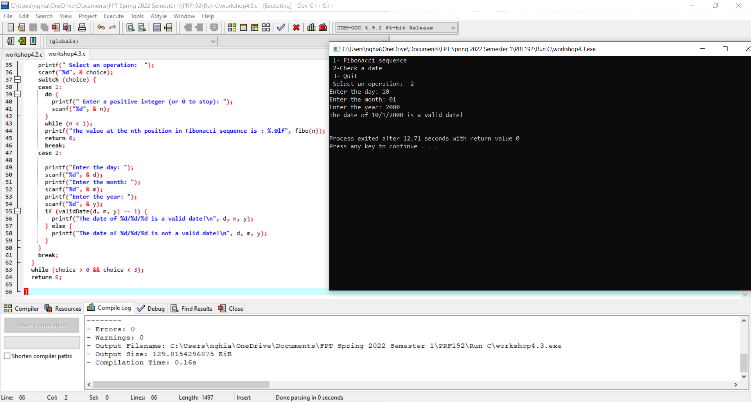

**More Programs**

You can pick 2 or 3 functions in the workshop 2, associate them to a new program.

